# VIDEO GAME SHOP

# MANAGEMENT

# SYSTEM

**SUBMITTED BY**

1. DIXIT VEDANT HARESH (24)
2. GAIKWAD SHIVAM GOPAL (25)



**Department of Computer Application**

**K.K.Wagh Arts, Commerce, Science and Computer Science College.**

**Nashik-422003**

**Academic Year 2020-21**



Karmaveer Kakasaheb Wagh Education Society’s

**K. K. Wagh Arts Commerce, Science, & Computer Science**

**College Saraswati Nagar Nashik-422003**

C E R T I F I C A T E

This is to certify that,

**Mr. DIXIT VEDANT HARESH and GAIKWAD SHIVAM GOPAL** have satisfactorily completed their project **VIDEO GAME SHOP MANAGEMENT SYSTEM** as fulfillment in **T.Y.B.B.A. (Computer Application)** Class for the academic year **2020-21**.

Project done by: Dixit Vedant & Gaikwad Shivam

Prof. V.H.Bava Project Guide (H.O.D)

Internal Examiner External Examiner

**ACKNOWLEDGEMENT**

We own our sincere gratitude to all those people who have given us their constant support and encouragement without which our project report would not have reached this stage.

We would like to express our thanks to Prof V.H Bava for her advice and encouragement. She has been a pillar of strength right through the project till the preparation of this report and helped by boosting morale, so we could surmount the difficulties that came across during completion of this project.

We would like to express our gratitude to Dr. A.P.Rajput, Principal, K.K.Wagh Arts, commerce, science and Computer Science College and Prof.V. H. Bava, Head of Computer Application department for the support and the infrastructure they have provided, so that we could successfully complete the project on time.

Last but not the list we would like to express our sincere thanks to all staff members and our friends for their help and cooperation in all phases of the project.

1. **DIXIT VEDANT (24)**
2. **GAIKWAD SHIVAM (25)**

**INDEX**

|  |  |  |
| --- | --- | --- |
| **Sr. No** | **Title** | **Page No.** |
|  | Problem Definition | 5 |
|  | Existing System | 6 |
|  | Proposed System | 7 |
|  | Requirement Analysis | 8 |
|  | H/W and S/W Requirement | 11 |
|  | Scope of The System | 13 |
|  | Feasibility Study | 14 |
|  | Entity Relationship Diagram (ERD) | 16 |
|  | Data Flow Diagrams (DFD) (0,1,2 level) | 17 |
|  | UML Diagrams | 20 |
|  | Data Dictionary | 28 |
|  | Sample I/O Screen | 30 |
|  | Conclusion | 42 |
|  | Future Enhancement | 43 |
|  | Bibliography | 44 |

**PROBLEM DEFINITION**

* The current system works on book-based documentation and record-keeping i.e. all the information is stored in books and registers which are stored in a record room after use and completion.
* A number of products i.e. Video Game CDs and DVDs and their information and status is required to be managed.
* A vast amount of customer details and information is required to be stored and managed.
* All stored data is at a risk of being lost, erased or misplaced.
* Data Corruption due to human calculation errors proves to be inevitable.
* Many people are employed in this system and each of them tend to carry out their particular tasks. All of the employees’ information and status also requires proper management and safe storage.
* Book-based management of the system includes a lot of paperwork which means high utilization of paper and paper products thus increasing the recurring cost for management.
* Work efficiency is decreased and time consumption is increased.

**EXISTING SYSTEM**

* The existing system does not have any security parameters as it does not include a secure login system. This may result into it being accessed by unauthorized personnel.
* The existing system lacks interactivity.
* The existing system functions on a book-based record keeping and data storage. This may lead to a severe loss of data which then, cannot be recovered.
* The existing system includes human labor hence there is a chance of errors in calculations or management.
* The existing system takes a large amount of time for a small amount of work to be carried out.
* This system is very time consuming, prone to errors or mistakes and may lead to loss of confidential or crucial information.

**PROPOSED SYSTEM**

* The proposed system is a GUI i.e. Graphical User Interface based experience for the system users with efficient record management and data storage.
* The proposed system includes a virtual product catalogue i.e Video Game CDs and DVDs and their particulars which makes it easier for both customers and employees to retrieve the games required.

.

* The new system is user friendly and super efficient.
* This proposed system consists of a well-managed and well maintained database system that stores and manages the important information required by the user.
* This system helps to keep easy track of the available data and can be retrieved easily when required.
* The new system is interactive.
* The proposed system has a user login system which provides high security for the stored information and thus, unauthorized access to the database system can be easily avoided.

**REQUIREMENT ANALYSIS**

Analysis of a new system is very crucial to conduct before making it actual. To study the system, the analyst needs to collect facts and all relevant information. The facts when expressed in quantative forms are termed as data. The success of any projects depends upon the accuracy of the available data. Accurate information can be collected with the help of certain methods/techniques. It is to minimize the risk factor.

These fact finding methods/techniques include:

* Observation
* Interview
* Questionnaires
* Record Review
* **Observation :**

In this technique, the system analyst participates in the organization, studies the flow of documents, applies the existing system, and interacts with the users. Observation can be a useful technique when the system analyst has a user point of view. A sampling technique called work sampling is useful for observation. By using this technique, system analyst can know how employees spend their days.

* **Interview :**

An interview is the most commonly used technique to collect information from the face to face interviews. The purpose of the interview is to find, verify, clarify facts, motivate end-users involved, identify requirements, and gather ideas and opinions. The role of the interview includes interviewer who is a system analyst and interviewee who are a system owner or user. The interviewing technique needs good communication skills for interaction between system analysts and users.

There are two types of interviews.

* **Unstructured Interviews :** An interview that is conducted with only a general goal or subject in mind and with few, if any, specific questions. Open-ended questions type is used in an unstructured interview that allows the user to answer freely in an appropriate way.
* **Structured Interviews** : A structured interview is an interview that contains a predefined set of questions. In a structured interview, close-ended questions type is used to limit answers to specific choices, short and direct responses from the interviewees.
* **Questionnaires :**

Questionnaires are also one of the useful fact-finding techniques to collect information from a large number of users. Users fill up the questions which are given by the system analyst and then give the answers back to the system analyst. Questionnaires can save time because the system analyst does not need to interview each of the users and if the time of the interview is short, questionnaires are more useful. To fulfill the requirements of the system objective, a system analyst should have the ability to clearly define the design and frame of questionnaires.

There are two types of questionnaires :

* **Free-format Questionnaires :** In free format questionnaires, users are allowed to answer questions freely without an immediate response. The results are also useful in learning about the feelings, opinions, and experiences of the respondents.
* **Fixed-format Questionnaires :** The purpose of fixed-format questionnaires is to gather information from the predefined format of questions. Users are allowed to choose the result from the given answers. There are three types of fixed-format questions: multiple-choice questions (Yes or No type), rating questions (Strongly Agree, Agree, No opinion, Disagree, Strongly disagree), ranking questions.
* **Record Review :**

The information related to the system is published in the sources like newspapers, magazines, journals, documents etc. This record review helps the analyst to get valuable information about the system and the organization.

**SYSTEM REQUIREMENTS**

**HARDWARE**

* Processor (CPU) : 1.6 GHz (or faster)
* RAM : 512 MB, 2 GB, 1 GB (32 bit - 1 GB, 64 bit - 2 GB)
* Free Hard Disk Space (HDD Space) : 3 GB
* Video Card (GPU) : -
* Display (Screen Resolution) : 1024 x 728 (DirectX 9)

**SOFTWARE**

* Microsoft Windows Operating System :
* Windows XP
* Windows Vista
* Windows 7
* Windows 8
* Windows 8.1
* Windows 10
* Microsoft Visual Basic Dot Net (Front End Support) :

“Visual Basic Dot Net” is mainly used for application programming for Microsoft Windows. It provides GUI (Graphical User Interface) for building application systems. Visual Basic Dot Net has emerged as one of the standard windows programming language and it has become a must for all software people for developing in a visual environment. Visual Basic Dot Net is developed from advance language. The latest version of VB is VB.Net. Visual Basic Dot Net provides facilities to connect database from MS Access, SQL Server and many more applications and can be used as front end.

* Microsoft Access (Back End Support) :

“Microsoft Access” is used in this project as back end. Microsoft Access provides various facilities like creating database, modifying database, editing database. Microsoft Access is called RDBMS, which stands for Relational Database Management System.

**SCOPE OF THE SYSTEM**

The existing system is manual. All the work is carried out by people and the records are maintained manually i.e. in books, registers or files. The proposed system for the Video Game Shop will be developed in Microsoft Visual Studio 2012 with VB.NET supporting the front end system, Microsoft Access 2007 supporting the back end of the application and some additional extensions (Guna UI 2) for enhanced GUI design.

This new system will allow users to quickly insert, delete, update and retrieve data from the system. The new system will provide safety and security of data by verification and authorization of its users. Only those with a valid ‘username’ and ‘password’ can gain access to the system.

**The scope of the system includes :**

* Storing information of customers, employees.
* Check validity of information provided by user.
* Storing information of members according to their IDs.
* Generating reports for different IDs.

**FEASIBILITY STUDY**

The first study aspect is whether the current project is technically feasible i.e. whether the project be carried out with the current equipment, existing software and available personnel. If new technology is required than what is the likelihood that it can be developed?

The second study aspect is whether the project is economically feasible i.e. are there sufficient benefits in creating the system to make the cost acceptable. Are the costs of not creating the system so great that the project must be undertaken?

The third study aspect is whether the project is operationally feasible or not i.e. whether the system will be used if it is developed and implemented? Project is worth developing only if it can meet institutions operating requirements.

The feasibility study proposes one or more conceptual solutions to the problem set for the project. The objective in assessing feasibility is to determine whether a development project has a reasonable chance of success. It helps us to determine the input & output of the system. The following are the criteria that are considered to confirm the project feasibility.

**The following feasibility study was undertaken for the proposed system:**

**Technical feasibility:**

At first it’s necessary to check that the proposed system is technically feasible or not & to determine the technology and skill necessary to carry out the project. If they are not available then find out the solution to obtain them. Hardware is already available in the collage.

**Economic feasibility:**

While considering economic feasibility, it is checked in points like performance, information and outputs from the system. MS Access is available in one package of the windows operating system & does not require additional software cost for the client tools. The cost incurred to develop the system is freeware & does not incur the cost to the project. Backend database technology is a freeware. This justifies economical feasibility of the system.

**Social feasibility:**

Although generally there is always resistance, initially to any change in the system is aimed at reliving the work load of the users to extent the system is going to facilitate user to perform operations like calculating salary amounts and deductions, generating reports with less possible errors. Thus there is no reason to make system socially unfeasible.

**ENTITY RELATIONSHIP DIAGRAM**

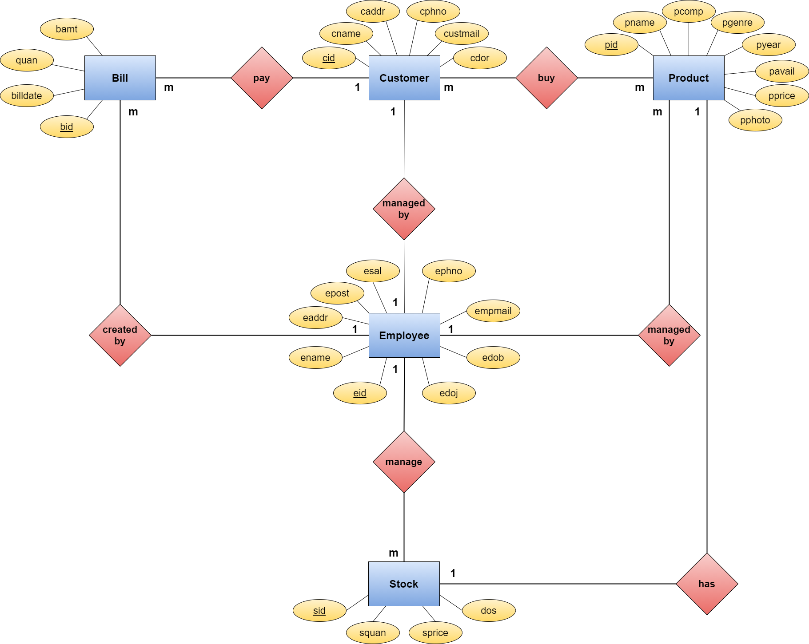

**DATA FLOW DIAGRAMS**

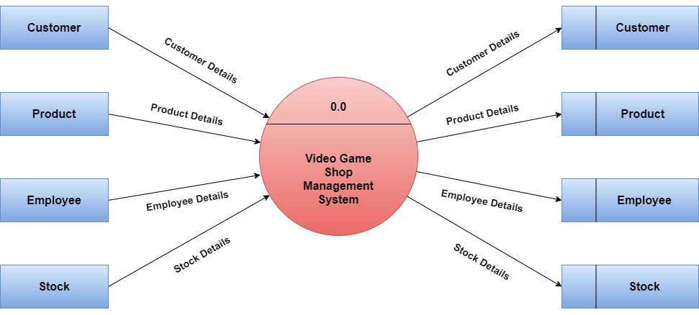**0TH LEVEL DFD**

**1ST LEVEL DFD**

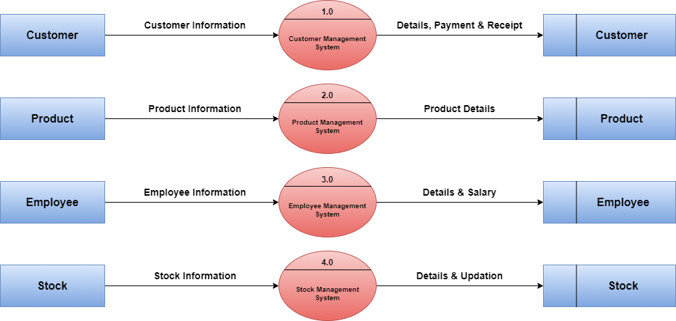

**2ND LEVEL DFD**

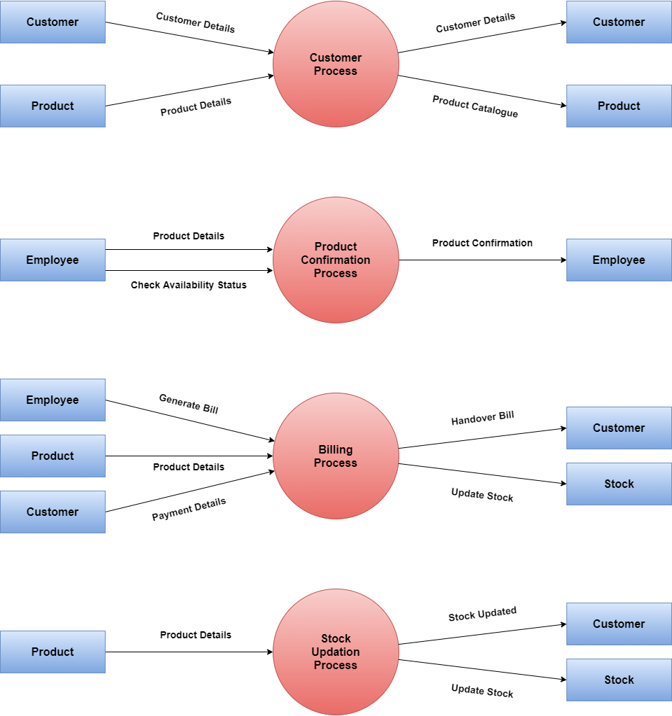

**UML DIAGRAMS**

**CLASS DIAGRAM**

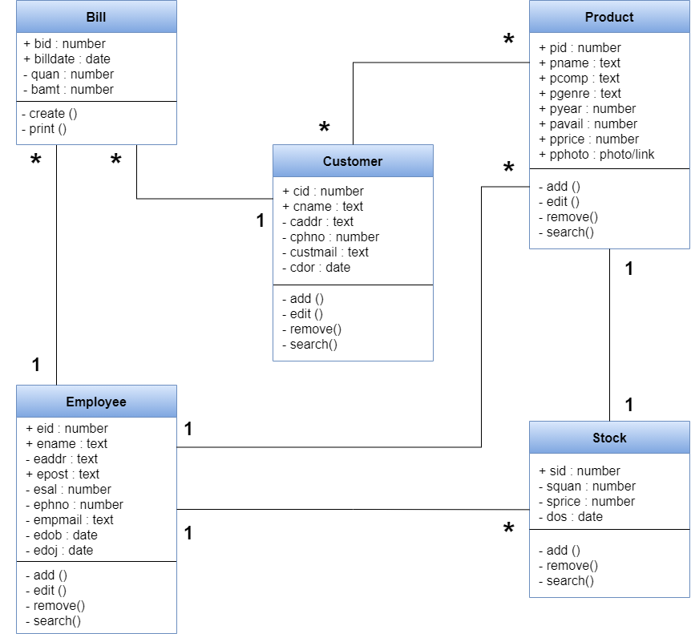

**ACTIVITY DIAGRAM**

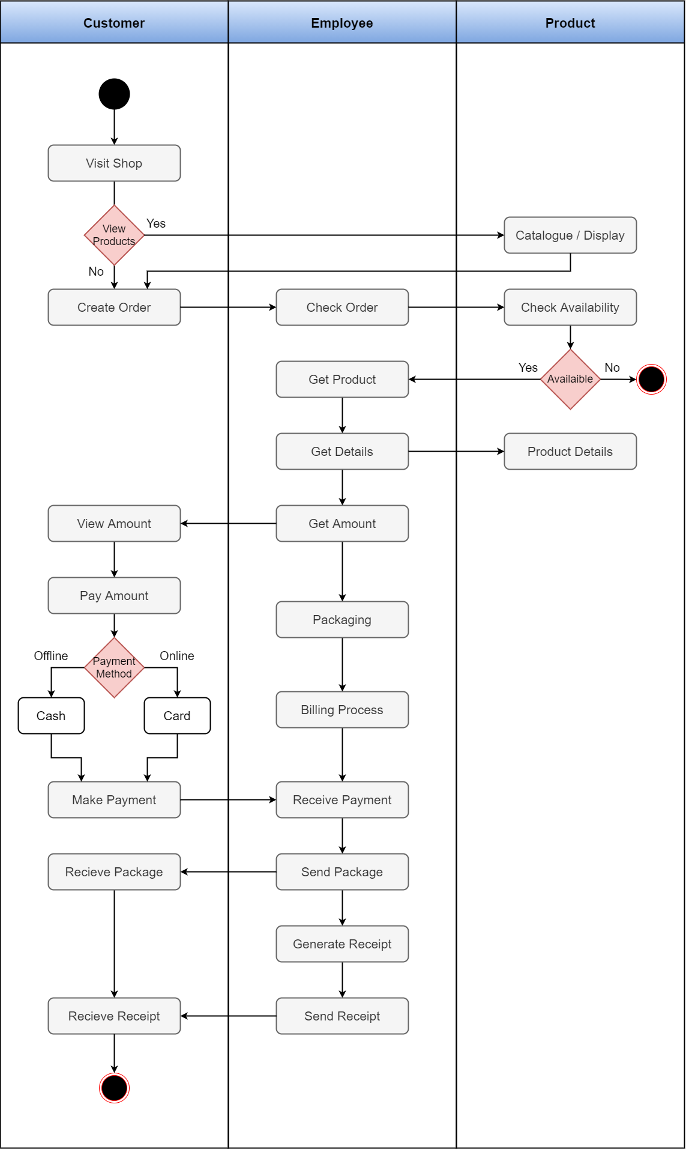

**SEQUENCE DIAGRA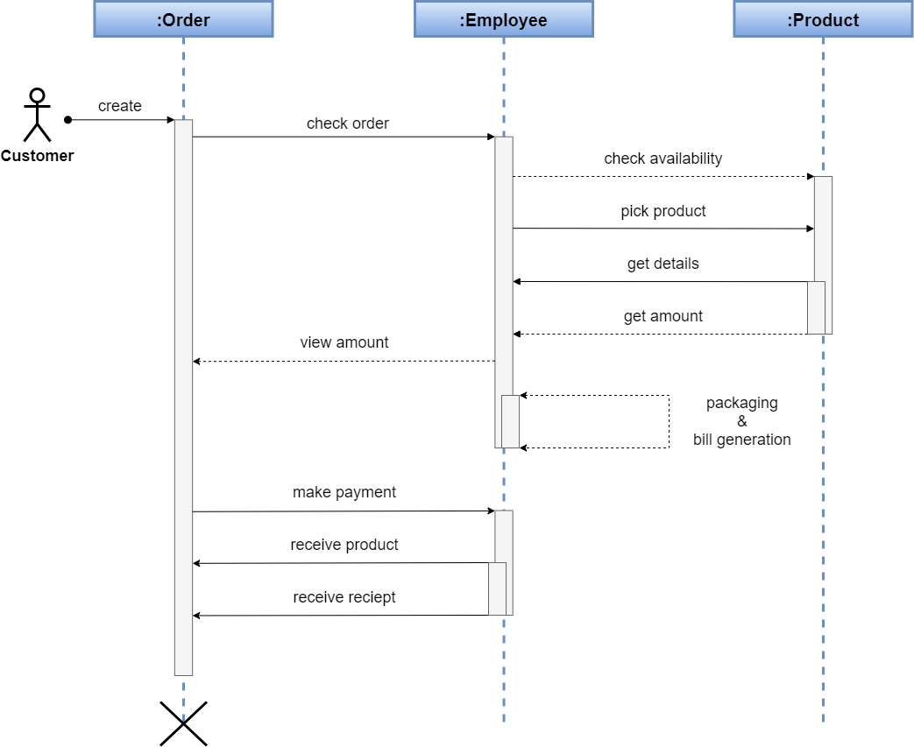M**

**DEPLOYMENT DIAGRAM**

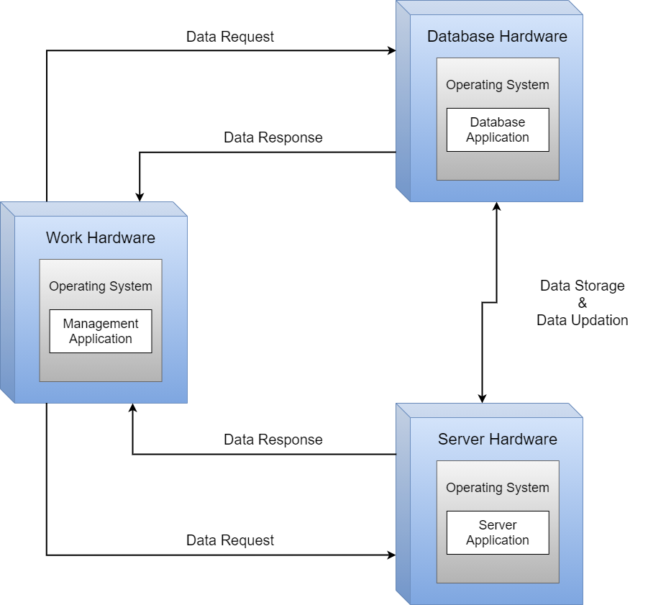

**USE CASE DIAGRAM**

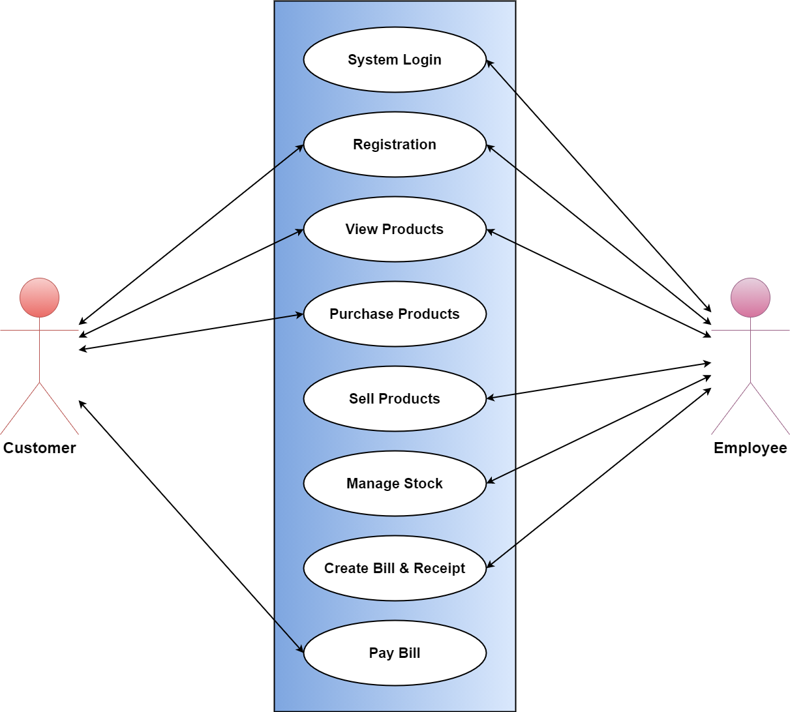

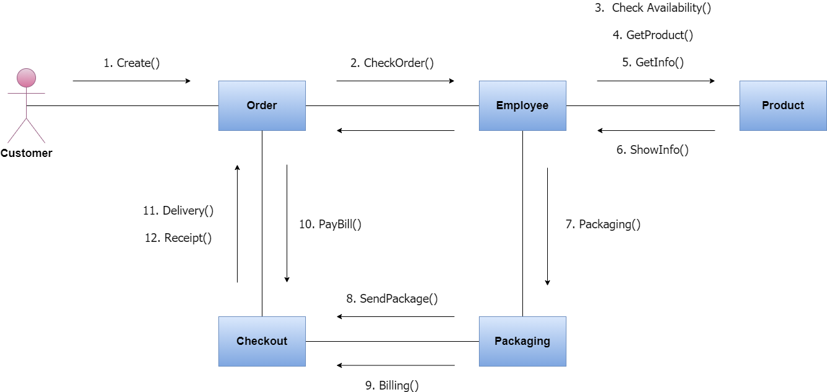**COLLABORATION DIAGRAM**

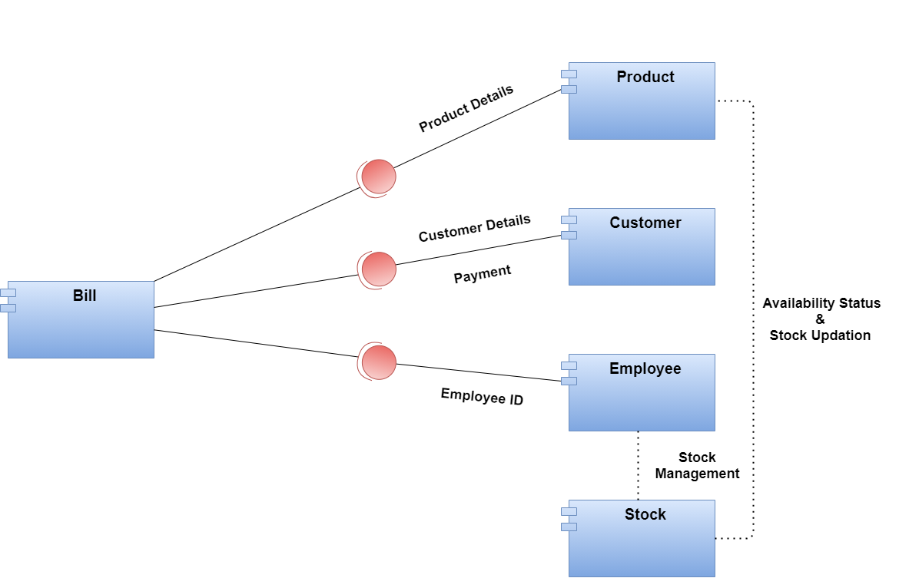**COMPONENT DIAGRAM**

**DATA DICTIONARY**

**CUSTOMER**

|  |  |  |
| --- | --- | --- |
| **FIELD** | **DATATYPE** | **DESCRIPTION** |
| cid | Number | Primary Key |
| cname | Text | Not Null |
| cadd | Text | Not Null |
| cphno | Number | Not Null |
| custmail | Text | - |
| eid | Number | Foreign Key |
| cdor | Date | Not Null |

**PRODUCT (i.e. Video Game CDs and DVDs)**

|  |  |  |
| --- | --- | --- |
| **FIELD** | **DATATYPE** | **DESCRIPTION** |
| pid | Number | Primary Key |
| pname | Text | Not Null |
| pcomp | Text | Not Null |
| pgenre | Text | Not Null |
| pyear | Number | Not Null |
| pavail | Number | Not Null |
| pprice | Number | Check (pprice > 0) |
| pphoto | Image/Link | Not Null |

**EMPLOYEE**

|  |  |  |
| --- | --- | --- |
| **FIELD** | **DATATYPE** | **DESCRIPTION** |
| eid | Number | Primary Key |
| ename | Text | Not Null |
| eaddr | Text | Not Null |
| epost | Text | Not Null |
| esal | Number | Not Null |
| ephno | Number | Not Null |
| empmail | Text | - |
| edob | Date | Not Null |
| edoj | Date | Not Null |

**BILL**

|  |  |  |
| --- | --- | --- |
| **FIELD** | **DATATYPE** | **DESCRIPTION** |
| bid | Number | Primary Key |
| cid | Number | Foreign Key |
| billdate | Date | Not Null |
| bamt | Number | Check (bamt > 0) |
| quan | Number | Check (quan > 0) |

**STOCK**

|  |  |  |
| --- | --- | --- |
| **FIELD** | **DATATYPE** | **DESCRIPTION** |
| sid | Number | Primary Key |
| pid | Number | Foreign Key |
| eid | Number | Not Null |
| squan | Number | Check (squan > 0) |
| sprice | Number | Check (sprice > 0) |
| dos | Date | Not Null |

**CUSTPROD**

|  |  |  |
| --- | --- | --- |
| **FIELD** | **DATATYPE** | **DESCRIPTION** |
| cid | Number | Foreign Key |
| pid | Number | Foreign Key |

**SAMPLE I/O SCREEN**

**MAIN MENU / DASHBOARD**

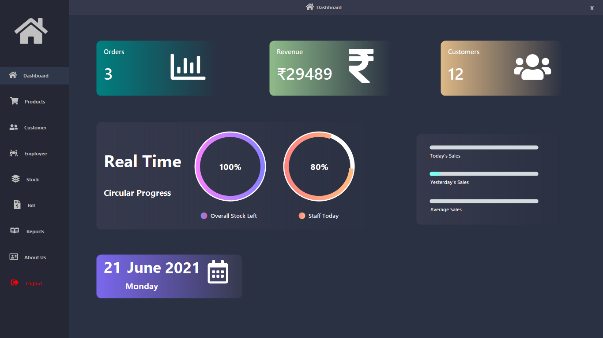

**PRODUCT DETAILS**

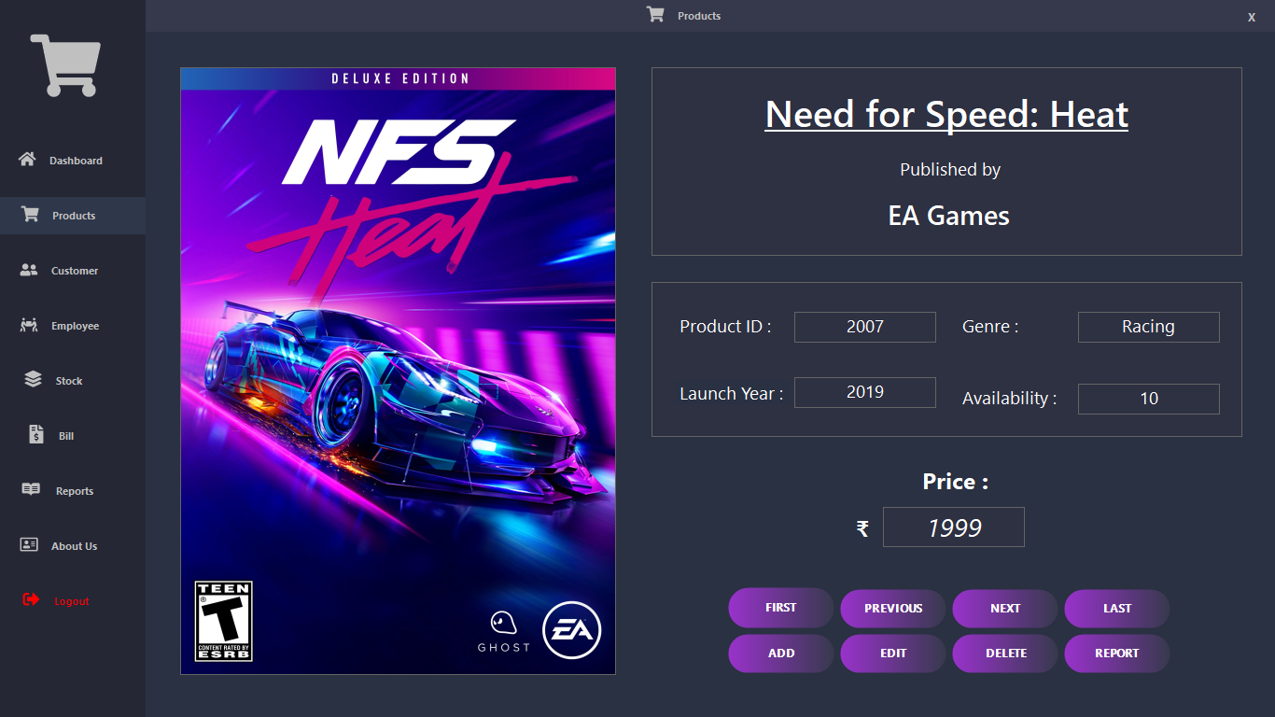

**EMPLOYEE DETAILS**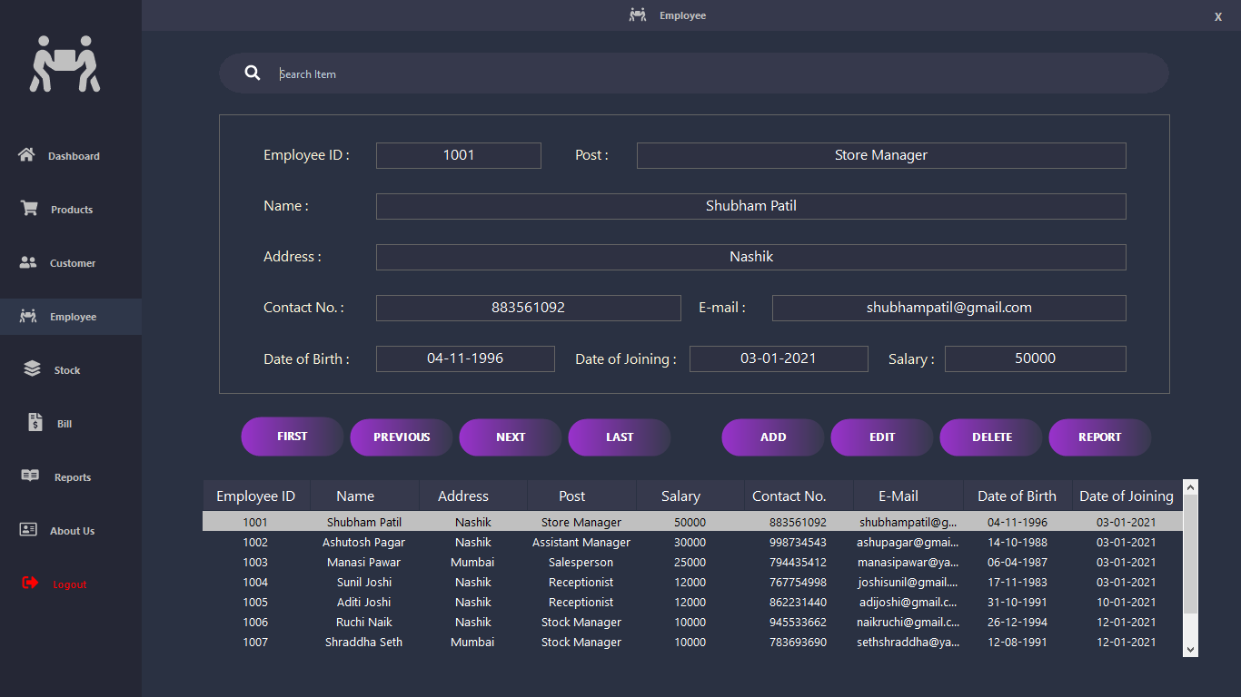

**CUSTOMER DETAILS**

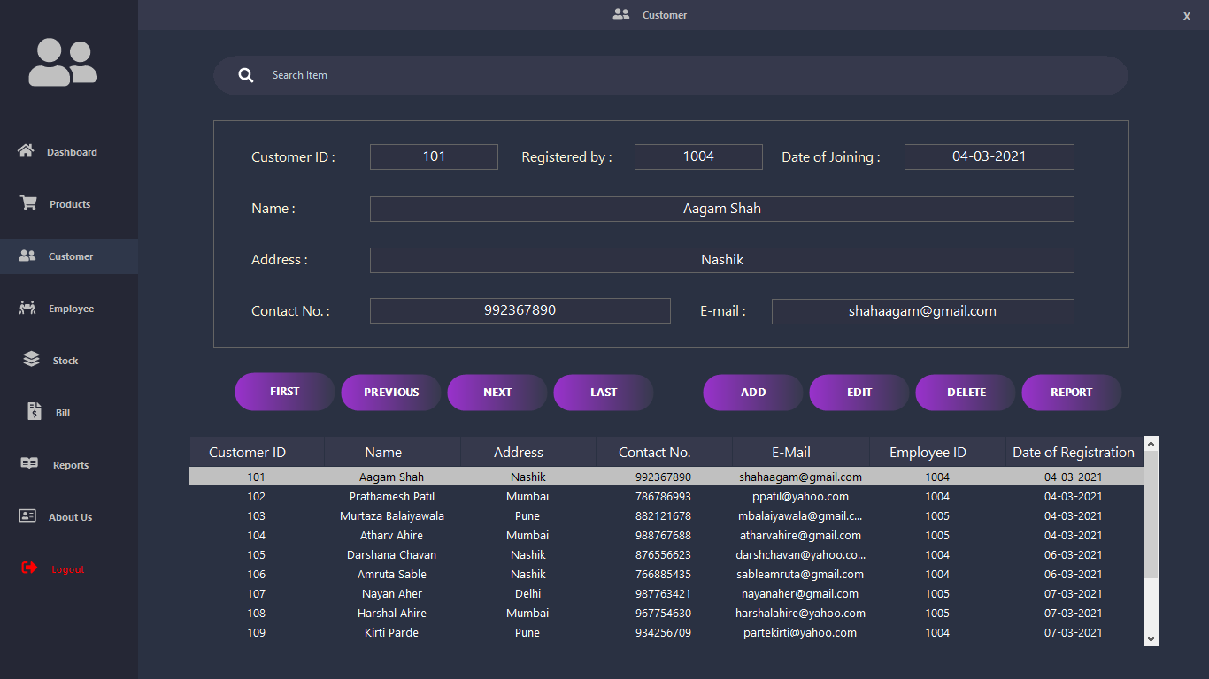

**STOCK DETAILS**

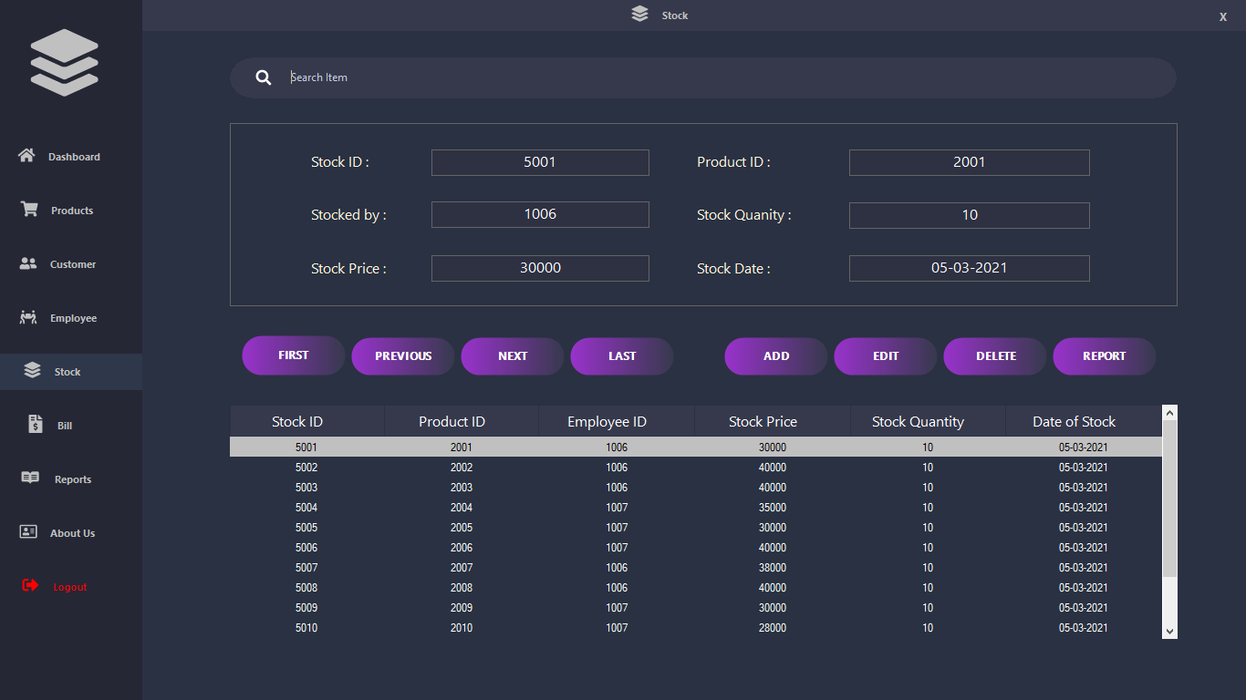

**BILLING & INVOICE RECIEPT**

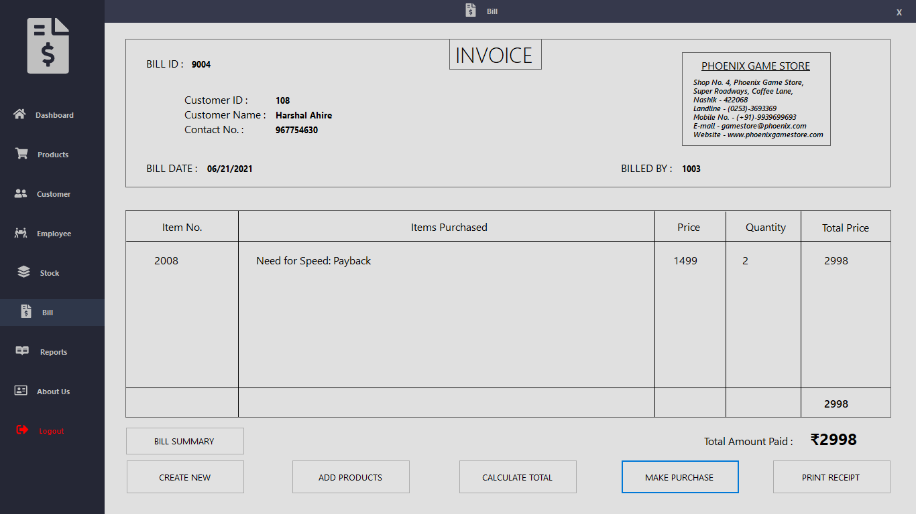

**PRODUCT REPORT**

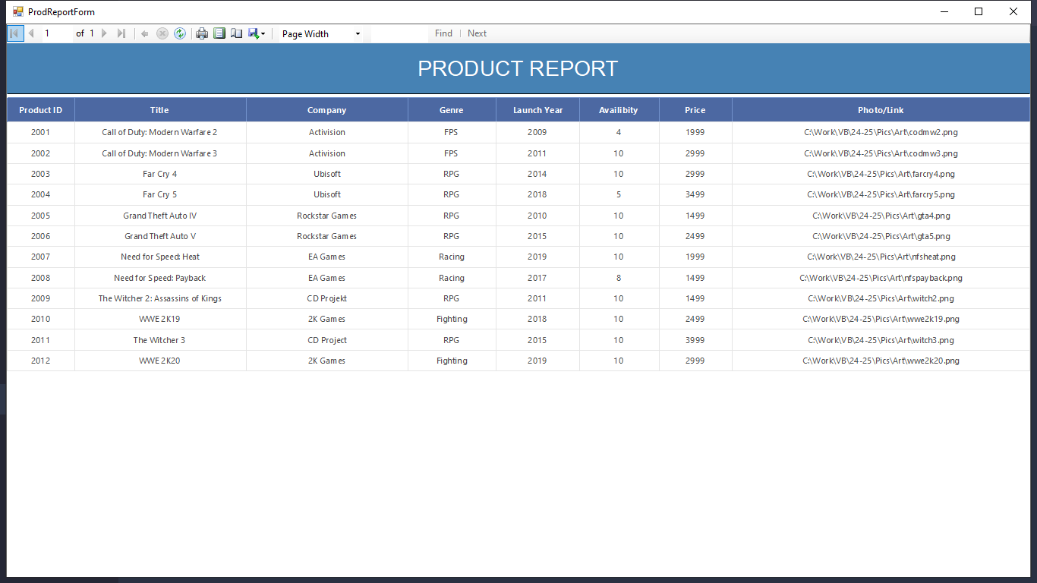

**CUSTOMER REPORT**

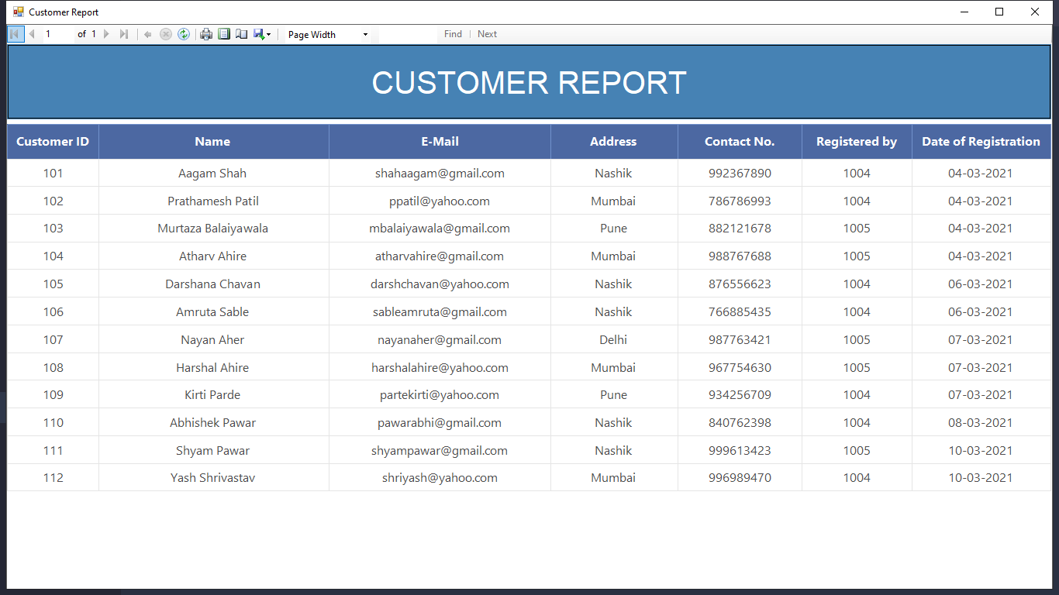

**EMPLOYEE REPORT**

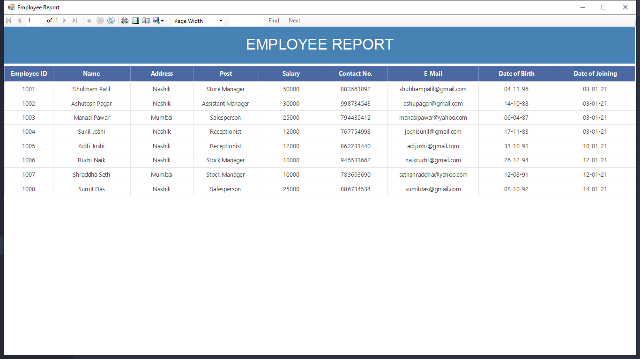

**STOCK REPORT**

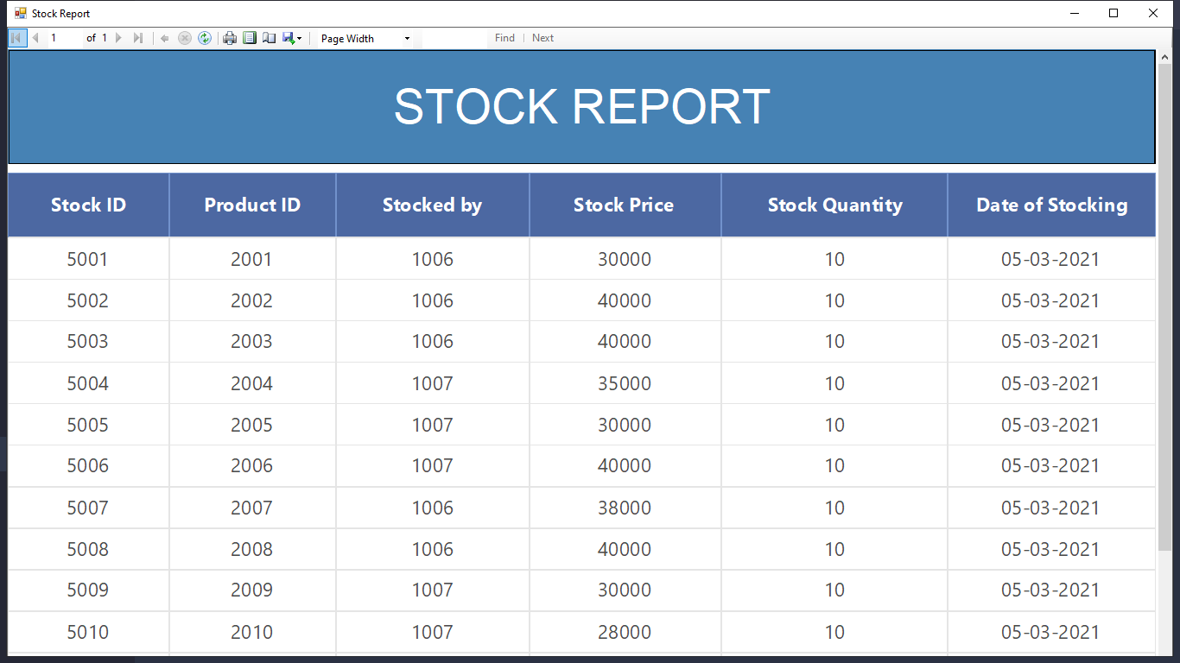

**BILLING REPORT**

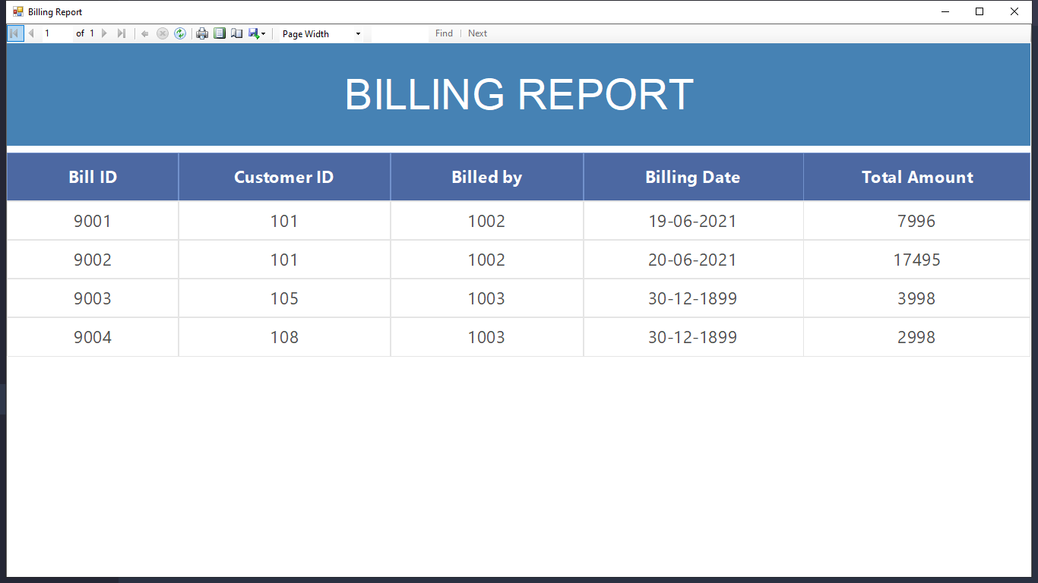

**CONCLUSION**

The “Video Game Shop Management System” is successfully designed and developed to fulfilling the necessary requirements, as identified in the requirements analysis phase, such as the system is very much user friendly, form level validation and field level validation are performing very efficiently.

The new computerized system was found to be much faster and reliable and user friendly then the existing system, the system has been designed and developed step by step and tested successfully. It eliminates the human error that are likely to creep in the kind of working in which a bulk quantity of data and calculations as to be processed.

The system results in quick retrieval of information that is very vital for the progress any organization. Cost is minimized in case of stationary. Burden of manual work is reduced as whenever transaction takes place, there is a no need to record it in many places manually.

**FUTURE ENHANCEMENTS**

The software has been developed in such a way that it can accept modifications and further changes. The software is very user friendly and future any changes can be done easily.

Software restructuring is carried out. Software restructuring modifies source code in an effort to make it amenable to future changes. In general, restructuring does not modify the overall program architecture. It tends to focus on the design details of individual modules and on local data structure defined within modules.

Every system should allow scope for further development or enhancement. The system can be adapted for any further development. The system is so flexible to allow any modification need for the further functioning of programs.

Since the objectives may be brought broad in future, the system can be easily modified accordingly, as the system has been modularized. The future expansion can be done in a concise manner in order to improve the efficiently of the system.

BIBLIOGRAPHY

Online References:

* *YouTube* : [www.youtube.com](http://www.youtube.com)
* *Stack Over Flow :* [www.stackoverflow.com](http://www.stackoverflow.com)
* *Javatpoint :* www.javatpoint.com